SELECT description

FROM crime_scene_report

where type = 'murder' and city = 'SQL City' and date = 20180115;

Security footage shows that there were 2 witnesses. The first witness lives at the last house on "Northwestern Dr". The second witness, named Annabel, lives somewhere on "Franklin Ave".

1 - ONE

SELECT *

FROM person

where address_street_name is 'Northwestern Dr'

order by address_number desc limit 1;

2 - ANNABEL

SELECT *

FROM person

where name like '%annabel%'

and address_street_name is 'Franklin Ave';

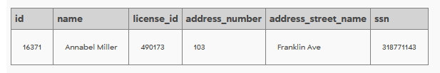

INTERVIEW MORTY

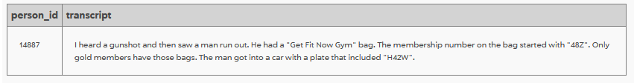

Get Fit Now Gun

Membership stating with 48Z (it's a gold member)

car plate including H42W

INTERVIEW ANNABEL

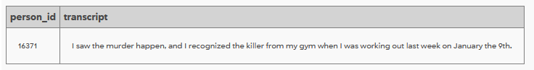

January 9th

SELECT *

FROM get_fit_now_member

where membership_status is 'gold'

and id like '48Z%';

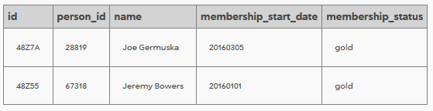

SELECT *

FROM drivers_license

where plate_number like '%H42W%';

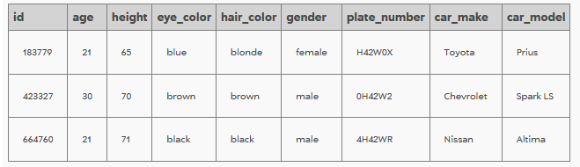

SELECT *

FROM person

where license_id = 664760 or license_id = 183779 or license_id = 423327;

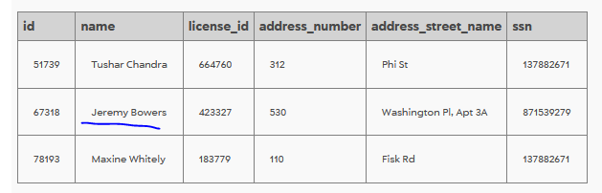

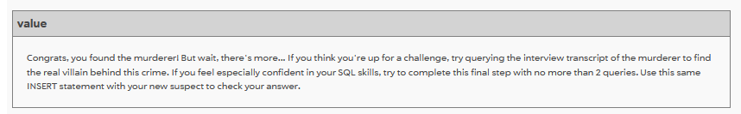

SELECT *

FROM interview

where person_id = '67318';

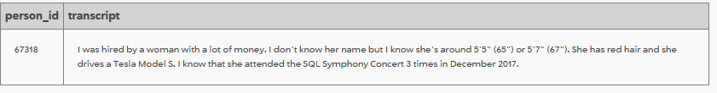

SELECT *

FROM drivers_license

where gender is 'female'

and hair_color is 'red'

and car_make is 'Tesla';

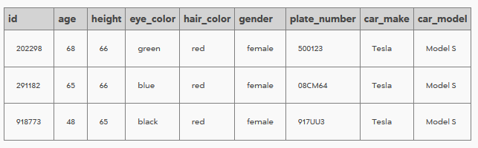

SELECT *

FROM facebook_event_checkin

where date like '201712%'

and event_name like '%Symphony%'

order by person_id;

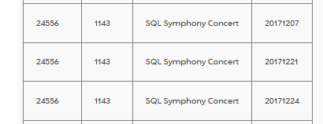

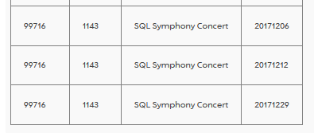

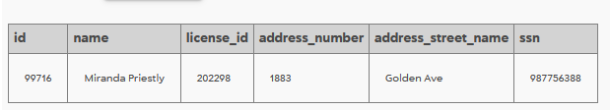

INSERT INTO solution VALUES (1, 'Miranda Priestly');

SELECT value FROM solution;

